

MINOR ASSIGNMENT REPORT ON

Software Engineering

CAL811

SUBMITTED BY SUBMITTED TO

ADITYA SHARMA Mr. Parveen Kr. Goyal
KID: K26798 (SOCAT), CPU, KOTA
COURSE: MCA

SCHOOL OF COMPUTER APPLICATION & TECHNOLOGY,
CAREER POINT UNIVERSITY, KOTA(RAJASTHAN)
S. No. | Topic | Page No.
1 | Introduction | 1
1.1 | Overview of Software Process | 1
1.2 | Importance of SDLC in Software Engineering | 2
2 | Software Process | 3
2.1 | Definition of Software Process | 3
2.2 | Need for a Structured Software Process | 4
3 | Umbrella Activities | 5
3.1 | Definition of Umbrella Activities | 5
3.2 | Detailed Explanation of Five Umbrella Activities | 6
3.3 | Diagram of Umbrella Activities | 8
4 | Comparison of Software Process Models | 9
4.1 | Waterfall Model | 9
4.2 | Incremental Model | 10
4.3 | Prototyping Model | 11
4.4 | Spiral Model | 12
4.5 | Comparative Analysis | 13
5 | Case Study: University Management System | 14
5.1 | Problem Statement | 14
5.2 | Task 1: Major Software Engineering Problems (Relating to Software Crisis) | 15
5.3 | Task 2: Suggested SDLC Model & Justification | 16
5.4 | Task 3: High-Level SDLC Diagram | 17
6 | Conclusion | 18
INDEX
Introduction
- Software development is not just coding—it’s about solving problems in a planned, systematic, and manageable way.
- Without proper planning, even a brilliant idea can fail due to delays, cost overruns, or poor quality.
- To avoid this, developers follow a software process, which acts like a roadmap for building reliable software.
- Every project is different. The right process model depends on factors like:
  - Project size & complexity
  - Team experience
  - Deadlines & budget
  - Client involvement
- Across all models, umbrella activities (risk control, quality checks, tracking progress) ensure that projects stay on track and high-quality.
👉 In this report, we will:
- Understand software process and umbrella activities.
- Compare four major process models (Waterfall, Incremental, Prototyping, Spiral).
- Apply these ideas in a case study (University Management System).

Assignment 1
Software Process

Definition
- A software process is the framework that defines what to do, how to do it, and in what order to build software efficiently.
- It ensures projects are:
  - Organized → clear steps, defined roles.
  - Controlled → track cost, time, and quality.
  - Predictable → avoid surprises and risks.

Why Do We Need It?
- To avoid chaos in large projects.
- To reduce cost & time wastage.
- To deliver quality software that meets client expectations.
- To standardize development across teams.
👉 In other Words, A software process is the roadmap that prevents projects from failing.

Umbrella activities
Umbrella activities are supporting tasks that apply across all phases of software development, no matter which process model (Waterfall, Spiral, Incremental, etc.) is used. These activities ensure that the development process is controlled, measurable, and of high quality. They act like a "safety net" to manage risks, maintain quality, and track progress.
The five main umbrella activities are:

1. Project Tracking and Control
- Definition: This activity ensures that the project is moving according to the planned schedule, budget, and objectives.
- Purpose: To monitor progress and take corrective actions whenever there is a deviation.
- Activities Involved:
  - Preparing schedules and assigning tasks.
  - Tracking progress of each phase (using charts, reports).
  - Identifying delays and bottlenecks early.
  - Taking corrective steps (adding resources, rescheduling tasks).
- Tools Used:
  - Gantt Charts (timeline-based tracking).
  - PERT/CPM Charts (dependency and critical path tracking).
  - Project Management Software (MS Project, Jira, Trello).
- Example: If coding is delayed, extra developers may be assigned to meet deadlines.
2. Risk Management
- Definition: Risk management is the process of identifying, analyzing, and preparing for risks that could threaten the success of a software project.
- Purpose: To minimize or eliminate potential problems before they occur.
- Types of Risks:
  - Technical Risks: New technology may fail.
  - Schedule Risks: Deadlines may be missed.
  - Cost Risks: Project may exceed budget.
  - Operational Risks: Team may lack skills.
- Steps in Risk Management:
  - Identify Risks (list possible issues).
  - Analyze Risks (find probability and impact).
  - Prioritize Risks (handle high-impact risks first).
  - Plan Risk Mitigation (prepare backup strategies).
- Example: If there is a risk of software being hacked, extra security testing is added.

3. Software Quality Assurance (SQA)
- Definition: SQA is a set of activities that ensure the software meets defined quality standards.
- Purpose: To guarantee that the final product is reliable, efficient, and satisfies customer needs.
- Activities Involved:
  - Process Standards: Following coding guidelines and documentation rules.
  - Testing: Unit testing, integration testing, system testing.
  - Audits & Reviews: Formal checking of documents, design, and code.
  - Error Prevention: Encouraging good practices to avoid bugs.
- Outcome: Produces defect-free, maintainable, and customer-acceptable software.
- Example: Ensuring every module passes unit tests before integration.

4. Technical Reviews
- Definition: A technical review is a formal assessment of software artifacts (like requirements, design, or code) by peers to identify errors and improvements.
- Purpose: To detect defects early (before testing stage) and improve quality.
- Types of Reviews:
  - Requirement Review – Check for missing or ambiguous requirements.
  - Design Review – Check system architecture for correctness and efficiency.
  - Code Review – Check coding style, logic errors, or performance issues.
- Benefits:
  - Saves cost by catching errors early.
  - Improves communication between team members.
  - Helps in knowledge sharing within the team.
- Example: Reviewing an algorithm design before coding to ensure it handles all test cases.

5. Measurement (Metrics Collection)
- Definition: Measurement involves collecting and analyzing quantitative data (metrics) about the process and the product.
- Purpose: To improve project management, predict outcomes, and support decision-making.
- Types of Metrics:
  - Size Metrics – Lines of Code (LOC), Function Points.
  - Effort Metrics – Person-hours, cost spent.
  - Quality Metrics – Defect density, error rates, test coverage.
  - Productivity Metrics – Output per unit effort.
- Uses of Measurement:
  - Tracking productivity.
  - Estimating future projects.
  - Finding process bottlenecks.
  - Improving overall quality.
- Example: Measuring the average number of defects per 1000 lines of code.

Assignment 2
Software Process Models

1. Waterfall Model
- Definition: Oldest model, works in linear sequential flow (step by step).
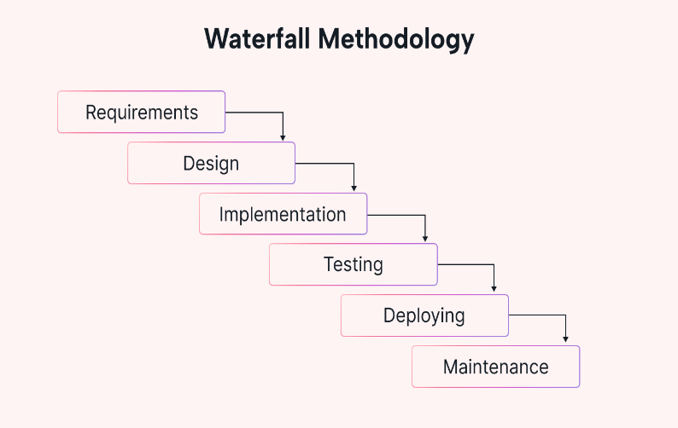
- Phases:
  - Requirements →
  - System Design →
  - Implementation (Coding) →
  - Testing →
  - Deployment →
  - Maintenance
- Advantages:
  - Simple, easy to understand.
  - Good for small projects with well-defined requirements.
- Disadvantages:
  - Very rigid, hard to make changes once a phase is completed.
  - Errors are discovered late (at testing stage).
  - Customer sees the final product only at the end.

2. Incremental Model
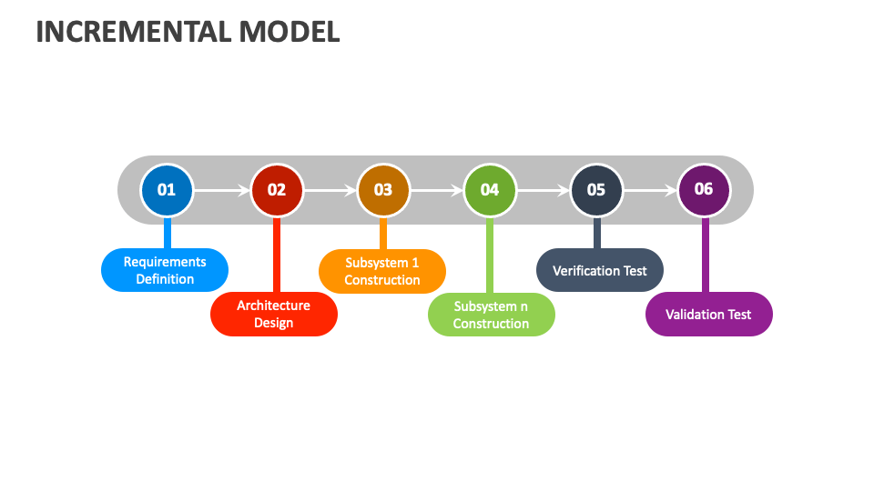
- Definition: The system is developed in increments (parts). Each increment delivers a working product.
- Process:
  - First increment → basic system.
  - Next increments → add features
until complete.
- Advantages:
  - Delivers software in parts, so customer gets early product.
  - Easier to test and fix issues incrementally.
  - Flexible, changes can be incorporated in later increments.
- Disadvantages:
  - Requires good planning and design.
  - If initial requirements are weak, increments may go in wrong direction.
- Best For: Medium/large projects with evolving requirements.

3. Prototyping Model
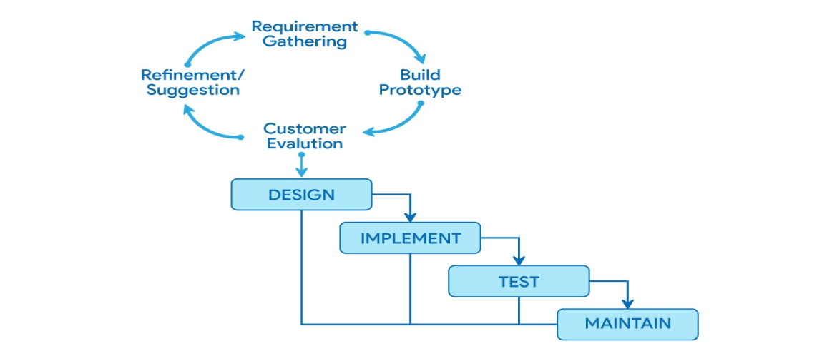
- Definition: Focuses on building a prototype (sample version) of the system to understand requirements better.
- Process:
  - Collect initial requirements.
  - Build a prototype (mock-up).
  - Show it to customer → get feedback.
  - Refine prototype until requirements are clear.
- Build final system. Advantages:
  - Helps clarify unclear/ambiguous requirements.
  - Customers get a feel of the system early.
  - Reduces risk of misunderstanding.
- Disadvantages:
  - Can be time-consuming and costly if many prototypes are needed.
  - Customers may expect prototype to be the final product.
- Best For: Projects where requirements are unclear (e.g., user interface-heavy systems)
4. Spiral Model
- Definition: Combines iterative development with systematic risk analysis.
- Process (Spiral Cycles):
  - Planning (objectives, alternatives).
  - Risk Analysis (identify, evaluate, resolve risks). Development (design, coding, testing).
  - Evaluation (customer feedback).
  - Repeat for next cycle until system is finished.
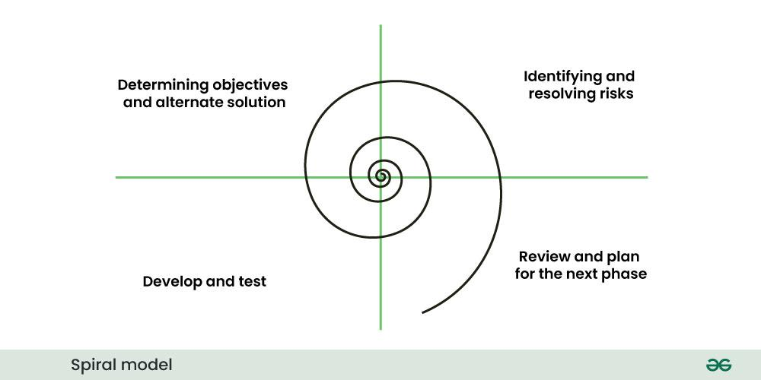
- Advantages:
  - Strong risk management.
  - Flexible and iterative.
  - Suitable for large, complex, and high-risk projects.
- Disadvantages:
  - Expensive due to risk analysis.
  - Requires expertise in risk management.
- Best For: Big projects like aerospace, defense, banking software.

Comparison

Aspect | Waterfall Model | Incremental Model | Prototyping Model | Spiral Model
Approach | Linear, step-by-step | System built in increments | Build prototype first, refine later | Iterative with risk analysis
Flexibility | Very rigid, hard to change | Flexible, changes in later increments | Very flexible (based on feedback) | Highly flexible
Risk Handling | Poor, discovered late | Moderate | Good for unclear requirements | Excellent (risk-driven)
Customer Involvement | Low (start & end only) | Medium (each increment) | High (continuous feedback) | High (in each cycle)
Cost & Time | Low for small projects, high for large | Moderate, faster delivery of working parts | Costly if too many prototypes | High (costly due to analysis)
Best Suited For | Small, well-defined projects | Medium to large, evolving needs | Projects with unclear requirements | Large, high-risk projects

Conclusion
The software process plays a vital role in the successful development of software projects. The five umbrella activities—project tracking, risk management, SQA, technical reviews, and measurement—support every model by ensuring quality and minimizing risks.
Among the process models, each has its own strengths and weaknesses:
- The Waterfall Model is simple but rigid.
- The Incremental Model delivers working software in parts, allowing flexibility.
- The Prototyping Model is best for unclear requirements, as it emphasizes feedback.
- The Spiral Model is the most powerful for large and risky projects, though costly.
Thus, the choice of model depends on the nature of the project, level of risk, clarity of requirements, and customer involvement. Selecting the right model is crucial for delivering successful software within time and budget.

Assignment 3
Case study
Problem Statement
A university is struggling with its manual system for managing student records, exam schedules, results, and faculty data. The current process leads to:
- Data redundancy (same information stored multiple times).
- Errors in records and result processing.
- Delays in publishing exam schedules and results.
- Difficulty in retrieving accurate data quickly.
- Lack of centralized management of student and faculty information.
This situation affects not only the administrative staff but also students and faculty, leading to inefficiency and dissatisfaction.

Objectives
The university needs a computerized University Management System (UMS) to:
- Maintain accurate student records (personal info, enrollment, courses).
- Manage faculty data (subjects handled, schedules, performance records).
- Automate exam scheduling and timetables.
- Simplify result generation and publishing.
- Reduce redundancy and human errors.
- Provide quick, centralized, and secure access to information.

Proposed Solution
The university should implement a University Management System (UMS) based on a database-driven software application.
Features of the Proposed System
- Student Management Module
  - Stores personal, academic, and attendance records.
  - Tracks course enrollments and performance.
- Faculty Management Module
  - Maintains teaching schedules, subject allocation, and faculty details.
  - Supports workload management.
- Examination Management Module
  - Automates exam schedule generation.
  - Prevents conflicts (faculty availability, classroom allocation).
  - Generates hall tickets and seating arrangements.
- Result Processing Module
  - Automates evaluation and result compilation.
  - Publishes results online securely.
- Reporting and Analytics
  - Generates reports for administration (student performance, pass rates).
  - Provides decision-making insights.
- Security & Access Control
  - Role-based access (Admin, Faculty, Student).
  - Secure login and data protection.

Benefits of the System
- Efficiency: Faster processing of records and results.
- Accuracy: Eliminates manual errors.
- Reduced Redundancy: Single, centralized database.
- Transparency: Easy access to exam schedules and results for students.
- Decision Support: Reports help management make better academic decisions.
- Scalability: Can handle increasing student and faculty data.
Case Study Tasks:
University Management System

Task 1:
Major Software Engineering Problems in the Current System (Relating to Software Crisis)
The university’s manual system suffers from several problems that directly relate to the Software Crisis issues in software engineering:
- Data Redundancy & Inconsistency
  - Same data (student/faculty info) is entered multiple times, leading to mismatched or outdated records.
- Errors in Record Keeping
  - Manual entry increases the chance of human errors, affecting exam results, attendance, and student records.
- Scalability Issues
  - As the number of students and faculty increases, the manual system cannot handle the growing complexity.
- Delayed Results & Inefficiency
  - Manual exam scheduling and result processing takes a lot of time, causing delays.
- Lack of Integration
  - No centralized system to link student data, faculty schedules, and exam results.
- Poor Reliability
  - Data may be lost, misplaced, or duplicated, making the system unreliable.
- Difficulty in Maintenance & Security
  - Paper-based/manual systems have weak data protection and are harder to maintain.
These problems reflect the Software Crisis challenges:
- Complexity of systems.
- Low productivity due to manual work.
- High error rate.
- Difficulty in managing large data and ensuring security.

Task 2:
Suggested SDLC Model and Justification
Suggested Model: Incremental Model
Justification:
- The University Management System is large and complex, so developing it in one go (like Waterfall) is risky.
- Requirements may change or evolve (e.g., adding new modules like Hostel, Library, or Online Exams later).
- The Incremental Model allows development in small parts (modules):
  - First Increment: Student & Faculty Management.
  - Second Increment: Examination Scheduling.
  - Third Increment: Result Processing.
  - Further Increments: Analytics, Online Access, etc.
- This ensures that the university starts getting a working system early, instead of waiting for the full system to be completed.
- Customer (university staff and faculty) can give feedback after each increment, reducing errors and improving satisfaction.
the Incremental Model is best suited here because it balances control, flexibility, early delivery, and feedback.

Task 3:
High-Level SDLC Diagram for the Proposed System
Here’s a simple Incremental SDLC diagram for the University Management System:

Diagram Description
- The process repeats for each incremen
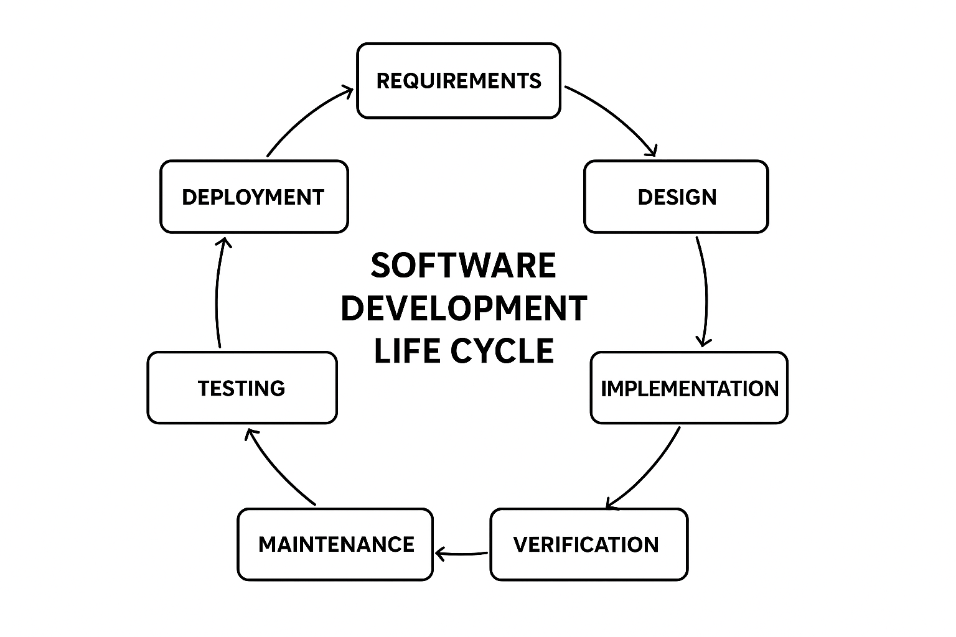

Conclusion
The manual system used by the university is inefficient, error-prone, and time-consuming. By implementing a computerized University Management System, the university can significantly improve data management, exam scheduling, result processing, and faculty record handling. This will lead to greater accuracy, efficiency, and transparency, benefiting both administrators and students.

